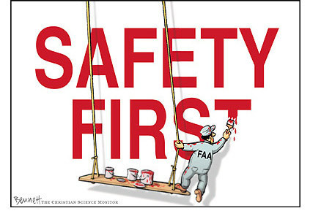
SAFETY RULES
- Please sign in on Visitor Log. Visitor Logs are located in lower warehouse and in the front office.
- Safety glasses are required throughout the plant. Steel toed shoes are required outside of designated safety zone. – No exceptions.
- Report all injures to Safety Department. No matter how small or severe, all injuries must be reported. If you are bleeding, please have a plant worker to get the ERT member to assist you.
- If you are going to enter a confined space you must fill out a Confined Space Entry Permit. This permit can be obtained from a Giles Chemical supervisor.
- Any equipment to be worked on must Locked, Tagged, & Tried before work begins. Please be sure to inform plant workers of equipment you will be working on or around.
- Always wear fall preventative equipment when it’s needed. If in doubt please ask someone.

I have read and understand these safety rules. I agree to adhere to these rules while visiting Giles Chemical, a division of Premier Magnesia, LLC.

Signature: _________________________ Visit With:______________ Date:____________

